# **How to create Widget Position**

## **What is the Widget Location?**

Widget location is where you can set your multiple widget in the back end and it will display on front end user **it is very much useful to maintain you same code at one place**

* Go to your backend admin panel
* Appearance >> Widgets
* Here you can see in the Left Panel all default widget which wordpress provide
* And on the RIght Panel it is widget position
* Simply drag and drop any widget from left panel to your widget position

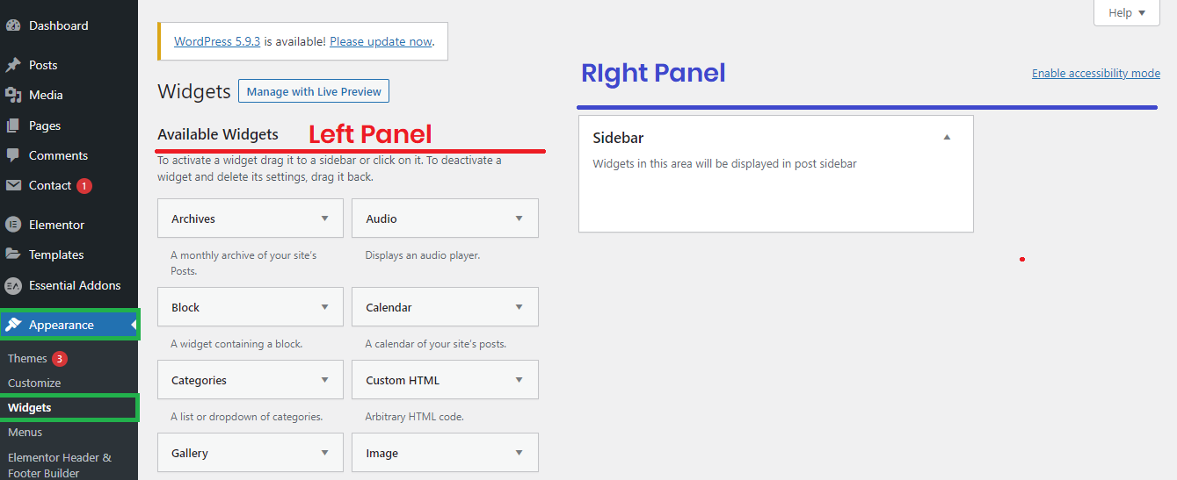

As per your active current theme it will give one or more widget position

In the above Screenshot it will only provide one widget position which is **Sidebar**

## **How to Create your custom widget position.**

1. Go to your active theme **function.php** file
2. Find this function **twentytwenty_sidebar_registration()**
3. You need to simple copy the code and paste just after inside the function

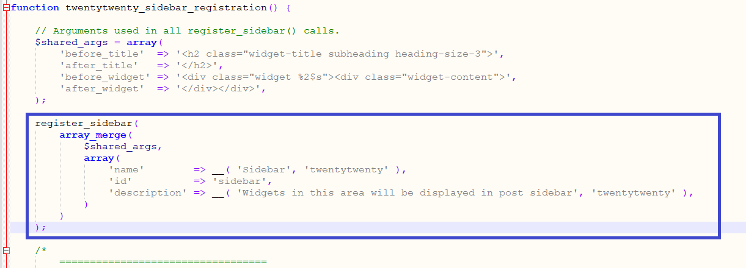

1. After past the code you need to change few thing

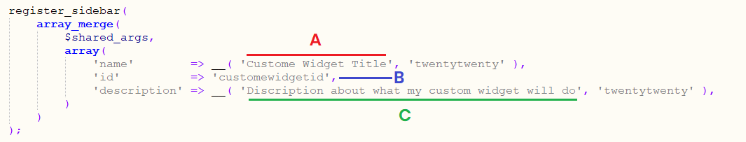

1. Title Of Your Widget >> which display only in admin panel
2. Your Custom Widget ID >> ID which is need when you need display this widget to the front end user. ID has to be small later, no space, use underscore
3. Widget Description >> add short description about where your widget will display on front end user so In future everyone know
4. Note: Everytime when you create new widget position you have to changes this 3 thing A, B, C must

**Here is the code >>**

register_sidebar(

array_merge(

$shared_args,

array(

'name' => __( 'Custom Widget Title', 'twentytwenty' ),

'id' => 'customewidgetid',

'description' => __( 'Description about what my custom widget will do', 'twentytwenty' ),

)

)

);

1. After following the above steps save your file and check in your backend panel your custom widget is there. Hurrrrrrryyyyyy.

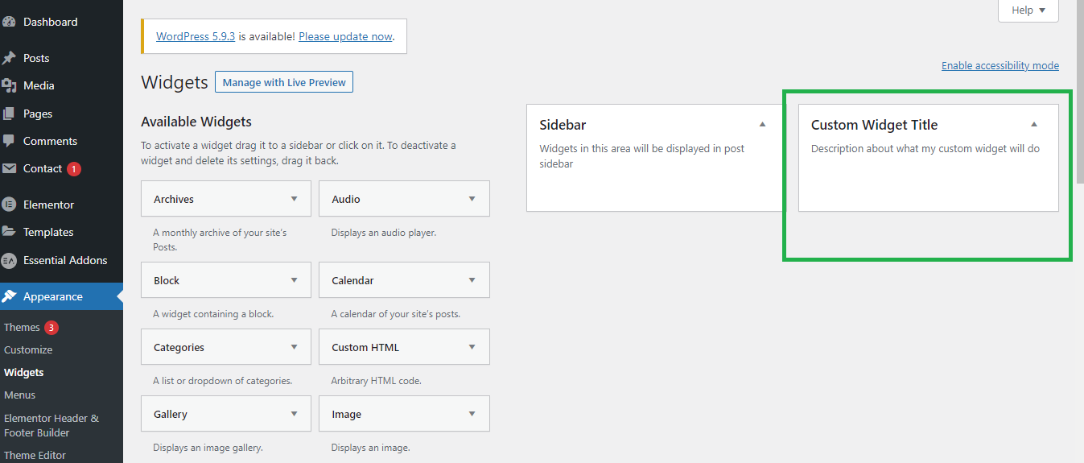

1. Now drag any widget from Left Panel and Drop in your Custom widget

**This will not display on frontend side YET**

## **How to Display your custom widget on the front side?**

1. Add some widget in your custom widget form backend in below screen we have added one text widget with title and description.

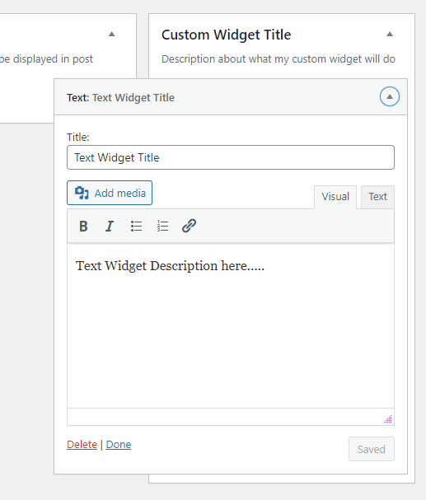

1. Go to your file where you want to display your custom widget in this demo i will go to header.php and add widget after the header

**Past this code>>**

<?php dynamic_sidebar( 'customewidgetid' ); ?>

You need to replace the ID what you have set in function.php while registering your widget

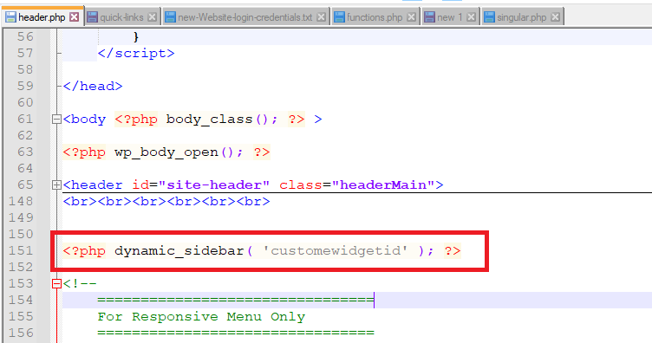

1. Run your website and you can see your widget which you have set in backend panel

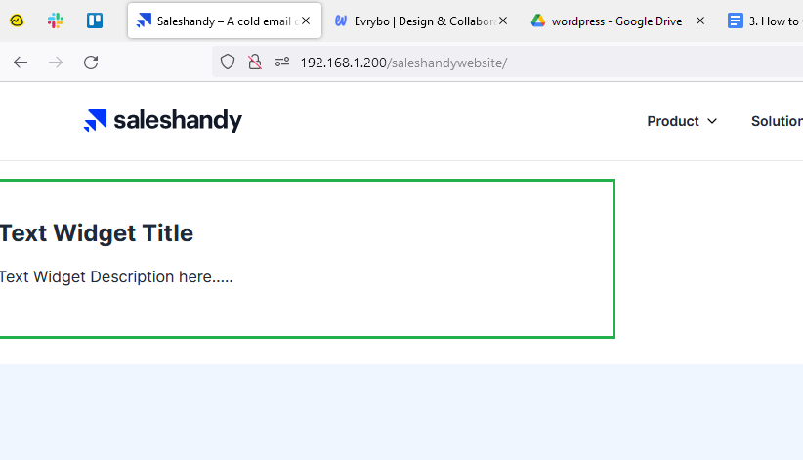

1. You can add multiple widget in your custom widget position

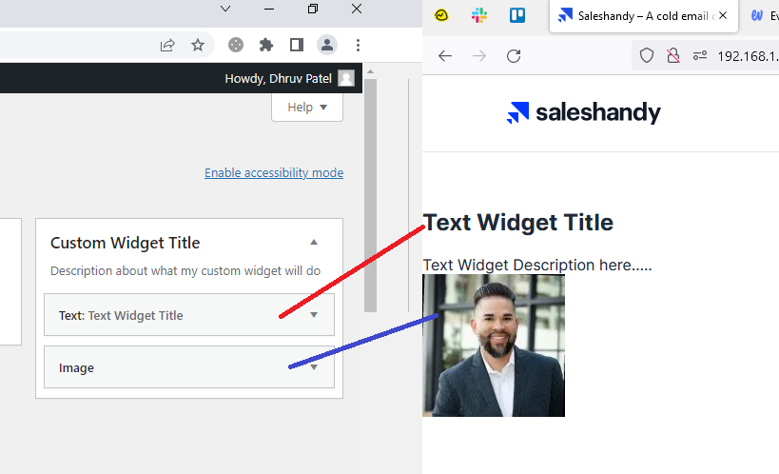

—-----------------------------------------------------------

All Done